Dynamic Web Project (installation)

1. Click "Help" > "Install new software"

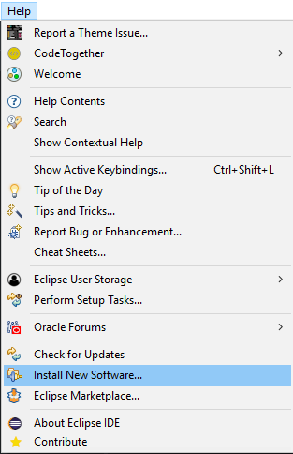

1. In "Work with", paste: <http://download.eclipse.org/releases/kepler>

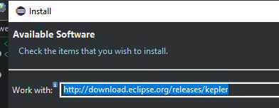

1. In "Web, XML, Java EE and OSGi Enterprise Development", check:

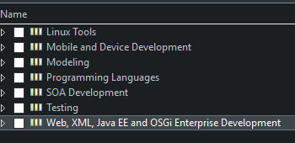

* + Eclipse Java EE Developer Tools
  + Eclipse Java Web Developer Tools
  + Eclipse Web Developer Tools
  + Eclipse XML Editors and Tools

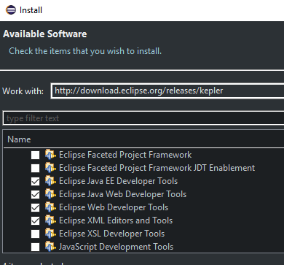

Finally, click "Next" to install the new software and "Dynamic Web Project" will be available.

